7. Implement Queue using Array
Aim:
To implement a queue using stacks and perform operation like enqueuer, dequeuer and display.

Algorithm:
Step 1: Start
Step 2: Initialize queue
Step 3: Initialize front and rear
Step 4: Display main menu
Step 5: Read user choice
If choice=1, go to equeue operation steps
If choice=2, go to DE queue operation steps
If choice=3, go to Display operation steps
If choice=4, go to Exit operation steps
Otherwise, print “invalid choice “ and return to Step 4
E Queue () operation Steps (choice =1)
StepE1: Check queue overflow
If rear==MAX-1, print “Queue overflow”and
return
StepE2: Read item to insert:
StepE3: Check if queue empty
StepE4: Increment rearrear =rear+1
StepE5: Assign queue element
Queue[rear]=item
StepE6: print success message and return to step 4
Dequeue () operation steps (choice =2)
StepD1: Check queue underflow
If front ==-1 or front > rear ,
Print “queue underflow” and return to step 4
StepD2: Print Deleted element
StepD3: Increment front
Front =front+1 and return to Step 4
Display () operation steps (choice=3)
Step Ds1: Check if queue is
If front ==-1 or front >rear
Print “Queue is empty “, return to Step 4
Step Ds2: Loop through queue
For I =front to rear
print queue[I]
Step Ds3: Return to main menu,
go back to step 4
Exit operation steps (choice =4)
Step x1: print Exit message
Step x2: End
Flowchart:
Queue Menu

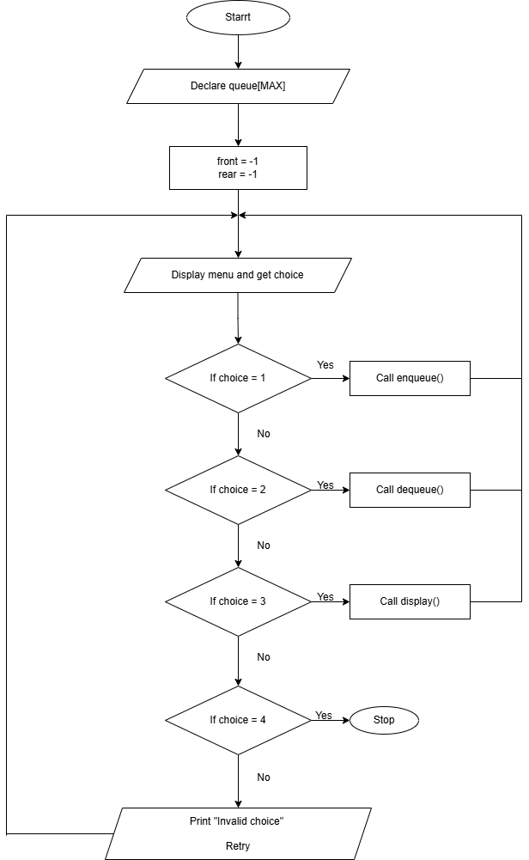

Enqueue:
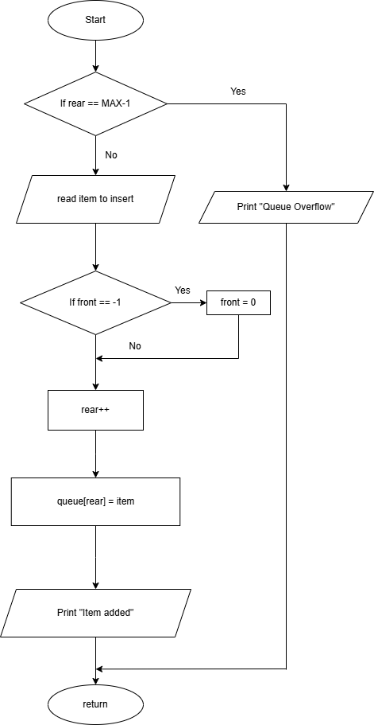

Dequeue:

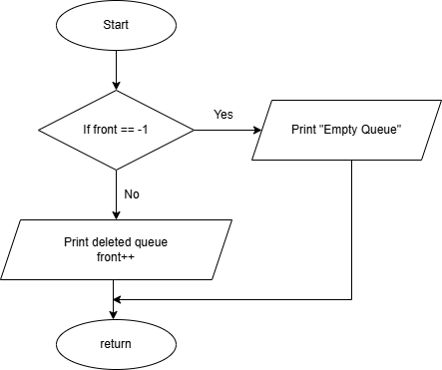

Display():

